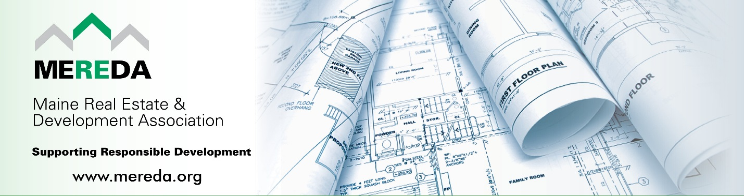

2023 Notable Project Awards Nominations
The Maine Real Estate & Development Association (MEREDA) is the state’s leading organization of commercial real estate owners, developers and related service providers and the only voice for the real estate development industry in Maine. Our efforts to promote responsible growth through fair and predictable legislation and regulation are vital for a return to a healthy, thriving economy.

Each spring MEREDA celebrates Real Estate Development in Maine by recognizing various development projects throughout the state that meet certain criteria such as “notable” and “significant”.

ELIGIBILITY: Projects will be chosen based in part on the following criteria:

- Noteworthy & Significant Project Completed* in 2023.
*Building Occupancy Permit must be Issued by December 31, 2023.
- Environmentally Sustainable
- Difficulty of the Development
- Uniqueness
- Economic Impact
- Energy Efficient
- Social Impact
- Job Creation

NOMINATION DEADLINE: All nominations must be received by November 30th to be considered.

NOMINATION REQUIREMENTS:
- FORMAT: Please submit your nomination(s) electronically using the following nomination application form.

- VISUALS: Feel free to submit images digitally with brief descriptions of each, and photo credits. In addition, please submit one photo contact sheet showing image thumbnails.

- REVIEW PROCESS: MEREDA’s Membership & Marketing Committee will review and make recommendations to MEREDA’s Executive Committee who will select the final recipients.

- NOTIFICATION: Recipients will be notified by email in early 2024.

- RECIPIENTS: Will be recognized at a MEREDA event in Spring 2024.

- CONTACT: Shelly R. Clark, Executive Director, info@mereda.org, 207-874-0801
Nominations are due November 30, 2023. Please submit this form to info@mereda.org

2023 Notable Project Awards Nomination Application
The following project is being nominated by: Date Submitted:

Your Name / Company Name:
Email:
Phone:

Nomination Details
Project Name: |  | Date Completed

Developer Name:

Location of Project:

Developer Contact Info:

Narrative (Blocks below will expand as you type.)

Please provide a brief description of the building and project (200 words max)

What makes this project noteworthy? (100 words ideal)

Environmentally Sustainable and Energy Efficient (200 words max)

2023 Notable Project Awards Nomination Application
Continued:

Job Creation and Economic Impact (200 words max)

As a result of this project, what has been the Social Impact? (200 words max)

What building features make this project unique to Maine? (200 words max)

Specifically, what challenges did you overcome to complete this project? (200 words max)

