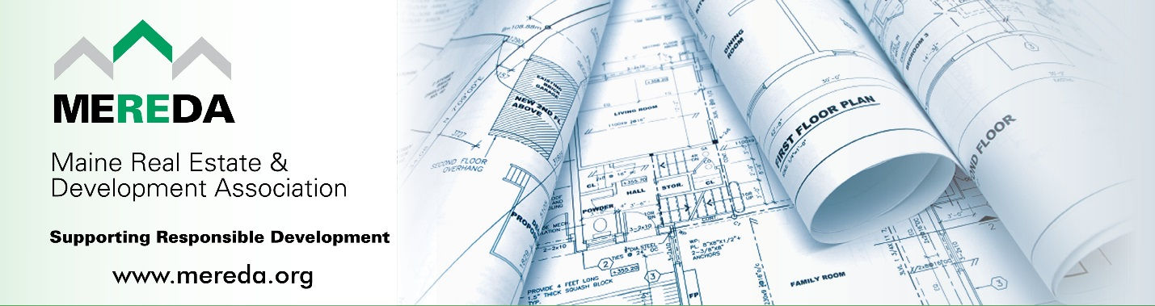

2025 Notable Project Awards Nominations
The Maine Real Estate & Development Association (MEREDA) is the state’s leading organization of commercial real estate owners, developers and related service providers and the only voice for the real estate development industry in Maine. Our efforts to promote responsible growth through fair and predictable legislation and regulation are vital for a return to a healthy, thriving economy.

Each spring MEREDA celebrates Real Estate Development in Maine by recognizing various development projects throughout the state that meet certain criteria such as “notable” and “significant”.

ELIGIBILITY: Projects will be chosen based in part on the following criteria:

- Noteworthy & Significant Project Completed* in 2025.
*Building Occupancy Permit must be Issued by December 31, 2025.
- Environmentally Sustainable
- Difficulty of the Development
- Uniqueness
- Economic Impact
- Energy Efficient
- Social Impact
- Job Creation

NOMINATION DEADLINE: All nominations must be received by January 15, 2026 to be considered.

NOMINATION REQUIREMENTS:
- FORMAT: Please submit your nomination(s) electronically using the following nomination application form.

- VISUALS: Feel free to submit images digitally with brief descriptions of each, and photo credits. In addition, please submit one photo contact sheet showing image thumbnails including descriptions and credts.

- REVIEW PROCESS: MEREDA’s Membership & Marketing Committee will review and make recommendations to MEREDA’s Executive Committee who will select the final recipients.

- NOTIFICATION: Recipients will be notified by email in early 2026.

- RECIPIENTS: Will be recognized at MEREDA's Notable Night event on April 30, 2026.

MEREDA is excited to be partnering once again with Mainebiz on the 2026 "Groundbreaking Maine" publication to be distributed in the 6/1/26 issue of Mainebiz focused on reporting on the real estate industry. One of the items featured will be coverage on MEREDA's Notable Project Recipients! They'll review each project and tell their story! Get your nominations in early!

- CONTACT: Shelly R. Clark, Executive Director, info@mereda.org, 207-874-0801

2025 Notable Project Awards Nomination Application
The following project is being nominated by: Date Submitted:

Your Name / Company Name:
Email:
Phone:

Nomination Details
Project Name:

Location of project:

Date (or anticipated date) completed:

Developer Name & Contact Info:

General
Contractor Name:

Architectural Team:

Engineering
Team:

Additional Support Staff to highlight (i.e. bank, other, etc

Narrative (Blocks below will expand as you type.)

Please provide a brief description of the building and project (200 words max)

What makes this project noteworthy? (100 words ideal)

Environmentally Sustainable and Energy Efficient (200 words max)

Job Creation and Economic Impact (200 words max)

As a result of this project, what has been the Social / Community Impact? (200 words max)

What building features make this project unique to Maine? (200 words max)

Specifically, what challenges did you overcome to complete this project? (200 words max)

Project Eligibility Confirmation

______ This project was completed in 2025 (Building Occupancy Permit issued by Dec 31, 2025)

_______ I confirm this project meets MEREDA's criteria

_______ I have contacted the developer / owner and have the authority to nominate this project on
their behalf.

